“SMART HUMAN RESOURCE & RECRUITMENT SYSTEM”

Mr. Varad Santosh Samudre, Miss. Ishwari Manik Wagh, Mr. Sandesh Sunil Kulkarni, Mr. Shriyash Sunil Thakare, Prof. S. K. Thakare

*Dept. of Information Technology, Pune Vidyarthi Griha's College of Engineering & SSDIOM Nashik 422004.*

----------------------------------------------------------------------***-------------------------------------------------------------------

**Abstract -**- Human resource is one of the most valuable assets in an organization. They are bounded to develop the unique and dynamic aspects that strengthen their competitive advantage to persist in an always changing market environment. In order to recruit a quality candidate for an organization, reducing human involvement and verifying details of the candidate is important in recruitment process. Furthermore, having an idea about how well or poor the employees perform, and how likely the employee attrition can occur is vital in human resource management process. This project is an attempt to introduce smart human resource management system that can maximize the productivity of an organizational environment using machine learning and blockchain technologies. The end goal of this research is a smart human resource management system that reduces human judgment, time in the candidate selection process andpredicts employee performance and attrition to motivate current employers to maximize productivity with minimal financial loss in the workplace environment. Skill assessment and resume classification have been done using unsupervised learning algorithms and natural language processing after extracting raw data from employee resumes using Object Character Recognition. Candidate details verification is done by comparing the hashes of the records which are stored in the block chain. Employee performance and attrition are predicted using supervised machine learning classification techniques with high accuracy and the result of the final performance is generated as a score for each employee considering The multiple attributes that has been standardized and regulated by some specifically considered e-competence frameworks. Education systems monitor student learning to provide some answers to these questions.

***Key Words*:** Machine Learning, Blockchain, LDA, Human Resource Management, Recruitment, Maximizing

**INTRODUCTION**

Human resources are one of the most valuable assets in an organization. They are bound to develop the unique and dynamic aspects that strengthen their competitive advantage to persist in an always changing market environment. In order to recruit a quality candidate for an organization, reducing human involvement and verifying details of the candidate is important in the recruitment process. Furthermore, having an idea about how well or poorly the employees perform, and how likely the employee attrition can occur is vital in the human resource management process. Many education systems monitor student learning to provide some answers to these questions. Comparative international analyses can extend and enrich the national picture by establishing the levels of performance being achieved by students in other countries and by providing a larger context within which to interpret national results. They can provide direction for schools’ instructional efforts and for students’ learning as well as insights into curriculum strengths and weaknesses. learning algorithms and natural language processing after extracting raw data from employee resumes using Object Character Recognition. Candidate details verification is done by comparing the hashes of the records which are stored in the blockchain. Employee performance and attrition are predicted using supervised machine learning classification techniques with high accuracy and the result of the final performance is generated as a score for each employee considering the multiple attributes that has been standardized and regulated by some specifically considered e-competence frameworks

**LITURATURE SURVEY**

1. **Data analysis and knowledge discovery in web recruitment—based on big data related jobs**

Year-2019

This paper proposed a convolutional neural network (CNN) based deep learning architecture for emotion detection from images. This paper mines and analyzes the post information of the online recruitment data, and discovers the knowledge in large-scale web data, so as to achieve the precise connection between professional job demand and supply. First, internet crawler technology is adopted to acquire data. Second, the authors digitalize polymorphic data and conduct Chinese word segmentation, stop word filtering and other operations on data records. Third, the cosine similarity is used to measure the similarity of the vector, and the K-means++ is used for post clustering. Then, latent dirichlet allocation and apriori are used for post correlation analysis. Last, the authors use auto-encoder to achieve job matching recommendation.

1. **The Blockchain as a Decentralized Security Framework**

The blockchain is emerging as one of the most propitious and ingenious technologies of cybersecurity. In its germinal state itself, the technology has successfully replaced economic transaction systems in various organizations and has the potential to revamp heterogeneous business models in different industries. Although it promises a secure distributed framework to facilitate sharing, exchanging and integration of information across all the users and third parties, it is important for the planners and decision-makers to analyse it in-depth for its suitability in their industry and business applications. The blockchain should be deployed only if it is applicable and provides security with better opportunities in obtaining increased revenue and reductions in cost. This article presents an overview of this technology for realization of security across distributed parties in an impregnable and transparent way.

1. **A Brain-Inspired Trust Management Model to Assure Security in a Cloud Based IoT Framework for Neuroscience**

Applications Rapid advancement of Internet of Things (IoT) and cloud computing enables neuroscientists to collect multilevel and multichannel brain data to better understand brain functions, diagnose diseases, and devise treatments. To ensure secure and reliable data communication between end-to-end (E2E) devices supported by current IoT and cloud infrastructures, trust management is needed at the IoT and user ends. This paper introduces an adaptive neuro-fuzzy inference system (ANFIS)brain-inspired trust management model (TMM) to secure IoT devices and relay nodes, and to ensure data reliability. The proposed TMM utilizes both node behavioral trust and data trust, which are estimated using ANFIS, and weighted additive methods respectively, to assess the nodes trustworthiness. In contrast to existing fuzzy based TMMs, simulation results confirm the robustness and accuracy of our proposed TMM in identifying malicious nodes in the communication network. With growing usage of cloud based IoT frameworks in Neuroscience research, integrating the proposed TMM into existing infrastructure will assure secure and reliable data communication among E2E devices.

1. **Smart Human Resource Management System to Maximize Productivity Year-2020**

Human resource is one of the most valuable assets in an organization. They are bounded to develop the unique and dynamic aspects that strengthen their competitive advantage to persist in an always changing market environment. In order to recruit a quality candidate for an organization, reducing human involvement and verifying details of the candidate is important in recruitment process. Furthermore, having an idea about how well or poor the employees perform, and how likely the employee attrition can occur is vital in human resource management process. This paper is an attempt to introduce smart human resource management system that can maximize the productivity of an organizational environment using machine learning and blockchain technologies. The end goal of this research is a smart human resource management system that reduces human judgment, time in the candidate selection process and predicts employee performance and attrition to motivate current employers to maximize productivity with minimal financial loss in the workplace environment. Skill assessment and resume classification have been done using unsupervised

**MOTIVATION**

According to diverse research, emotion plays an important role in education. Currently, a teacher uses exams, questionnaires and observations as sources of feedback but these classical methods often come with low efficiency. Using facial expression of students, the teacher can adjust their strategy and their instructional materials to help foster learning of students. It might have happened with many of the teacher’s lecturers that they are teaching something and the students are not listening or they are not interested in that particular topic or they are responding to the teacher if they ask any questions in the class, this may result in students’ poor performance in the exam or in future anywhere. It might also happen that a therapist or a psychiatrist feel like if they could know what is the current mind state or mood of the patient, in this way they could conduct a better therapy session. This gave us the idea of preparing this project idea and making it possible to be able to know that if the students are attentive in the lecture or if the patients are satisfied by the psychiatrist’s advice to apply in life

**PROBLEM DEFINITION**

Human resources are one of the most valuable assets in an organization. They are bound to develop the unique and dynamic aspects that strengthen their competitive advantage to persist in an always changing market environment. Many education systems monitor student learning to provide some answers to these questions. Comparative international analyses can extend and enrich the national picture by establishing the levels of performance being achieved by students in other countries and by providing a larger context within which to interpret national results.

**AIM & OBJECTIVES**

* The main aim for developing this project is to get vacancy for fresher students
* To create a better environment for the company and their employee.
* To give the better knowledge of student’s mood or interest level in the lectures or in the counseling sessions to the teachers.

**PROPOSED SYSTEM**

In our proposed system to reduce human judgment in resume classification by introducing a topic modelling- based resume scoring system and a person-skill visualization using high dimensional space. To motivate current employers by discovering potential talents and maximizing productivity in the workplace environment by predicting employee’s performance. To minimize financial loss in the organization by predicting employee attrition and analyzing reasons for the retention. To prevent fraud and reduce time with the integrity in employee details verification process by using block chain technologies. A basic profile of knowledge and skills among students at the end of compulsory Colllege.Contextual indicators relating results to student. By the Skill Exam Student will get his/her internal skill and also recommend best organization.

**SYSTEM ARCHITECTURE**

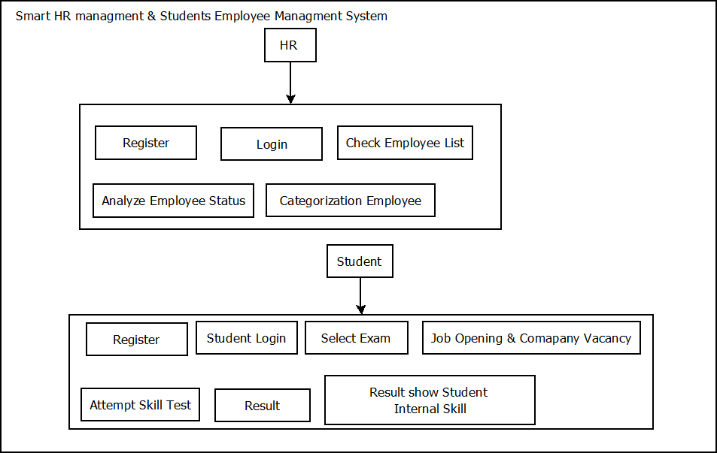

**Fig -1**: System Architecture Diagram

**APPLICATION:**

1. Colleges
2. Corporate Sector
3. Government Sector

**Software Requirements**

* Xampp 1.8.2
* Visual Studio

**Operating system:** Windows OS

**Technology:** PHP, MySQL, Naïve Bias Algorithm, Blockchain

**Back end:** MySQL 3.5.3

**Hardware Requirements**

* Processor: Minimum i3 and above
* RAM: 1 GB or above
* HDD: 256 GB or more

.

**RESULT**





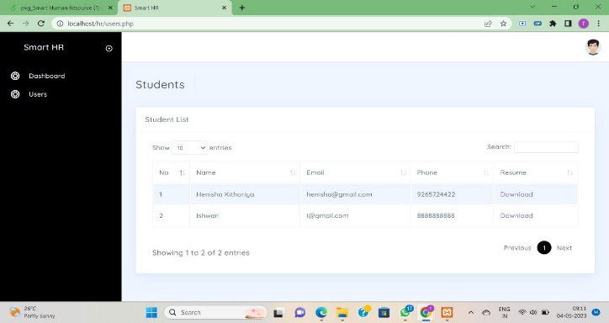

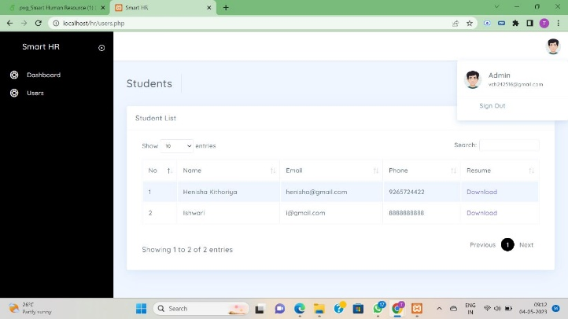

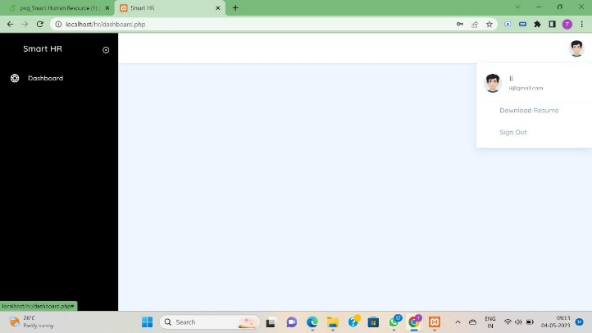

**CONCLUSION**

Implementing Smart Human Resource Management System as well as achieving above mentioned objectives through the system are met successfully. The proposed model on Employee Performance aids decision-makers and HRM to take instantaneous decisions about the employees for the growth of the organization as it focuses on the capabilities of employees and generating a rating-based analysis on their performance. As future dimensions, to extract data from employee resumes, a NER approach would work much better than a rule-based approach if can get a labeled resume data set suitable for the company. Big companies with many employees would benefit very well with such an approach. However, rule-based approach still works best for smaller companies with a smaller set of resumes if resumes contain relevant

**REFERENCES**

[1] Chen Zhu, Hengshan Zhu, Hui Xiong, Peng liang Ding, and Fang Xia, “Recruitment market trend analysis with sequential latent variable models”, Proceedings of the 22nd ACM SIGKDD International Con-ferrous on Knowledge Discovery and Data Mining, Aug. 2016, doi:10.1145/2939672.2939689..

[2] J. Chen, K. Li, Z. Liu, T. Zhang, W. Wen, Z. Song, Y. Wang, Y. Jin, and T. Huang, “Data analysis and knowledge discovery in web recruitment—based on big data related jobs”, 2019, pp. 142–146./.

[3] V. Mohanraj, R. Lakshmikanthan, M. Chandrasekaran, J. Senthil Kumar, and Y. Suresh, “Intelligent agent-based talent evaluation engine using knowledge base”, 2009, pp. 257–259.

[4] International Human Rights Instruments, International Recruitment Integrity System, 2020. [Online]. Available: https ://iris.iom.int/iris standard. [Accessed 2020-02-21].

[5] Singhal A. and S. Pavithra R., “Degree certificate authentication using arcade and smartphone”, International Journal of Computer Applications, vol. 120, 2015, pp. 38–43.

[6] “What it means to ‘Know Your Customer’”: <https://complyadvantage.com/knowledgebase/kyc/>.

[7] M. Castro and B. Lesko, “Practical Byzantine Fault Tolerance”, In Proceedings of the Third Symposium on Operating Systems Design and Implementation (OSDI ’99). USENIX Association, Berkeley, CA, USA, 173-186, 1999.

[8] N. Garg, “Apache Kafka. Packet Publishing”, 2013.

[9] “IBM Blockchain Platform”: https://console.bluemix.net/docs/services/blockchain/index.htmibmblockchain-platform.

[10] “Hyperledger Fabric v0.6.1: Protocol Specification”: https://github.com/hyperledger/fabric/blob/v0.6.1-.